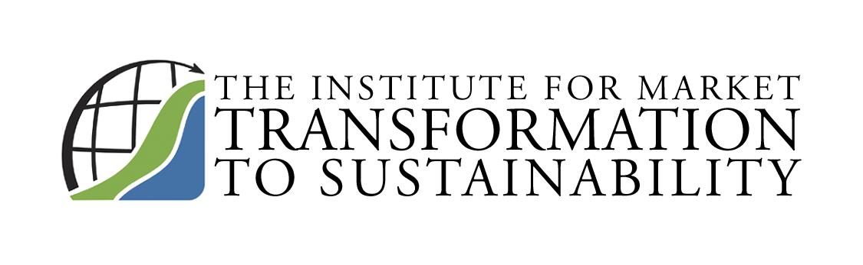
1511 Wisconsin Avenue, NW
Washington, DC 20007

Telephone 202-338-3131
Fax 202-338-2800
Email MTS@sustainableproducts.com
Web http://MTS.sustainableproducts.com MTS@sustainableproducts.com 202-338-2800

_____________________________________________

Membership Principles & Application Form
Statement of Principles: MTS is a 501(c)(3) public charity whose mission is to accelerate the global market transformation to sustainability and achieve 90% sustainable products market penetration by 2015. All MTS Members commit to achieving this goal and recognize their fiduciary duty to support the organization.
Name: _____________________________________
Entity: _____________________________________
Address: ______________________________________________________________
______________________________________________________________
Date: _____________________________________
Annual Membership Dues are as follows:
Manufacturers (gross annual sales of parent co.)
Less than $1M - $500/yr.
$1M - $50M annual sales of parent - $2500/yr.
$50M & higher - $5k/yr. Committee, $10k/yr. Board
Manufacturing Trade Associations (consistent with MTS Trade Association Policy)
$10k/yr. Committee, $15k/yr. Board
Government (population)
1M or less - $1k/yr.
Greater than $1M - $1500/yr.
Professional firms (annual revenue)
$500k or less - $500/yr.
$501k - $999k - $750/yr.
$1M - $2M - $1k/yr.
Greater than $2M - $1500/yr.
Nonprofit 501(c)(3) Environmental Groups
$500/yr.
Nonprofit Associations Excluding Manufacturers (annual budget)
$500k or less - $500/yr.
$501k - $999k - $750/yr.
$1M - $2M - $1k/yr.
Greater than $2M - $1500/yr.
Real Estate, Finance, Utility & Retail (gross annual sales of parent co.)
Less than $1M - $500/yr.
$1M - $50M annual sales of parent - $2500/yr.
$50M & higher - $5k/yr. Committee, $15k/yr. Board

