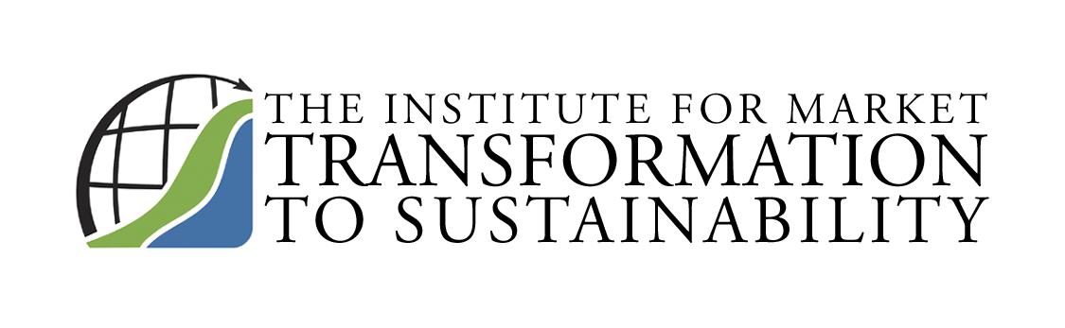
1511 Wisconsin Avenue, NW
Washington, DC 20007

Telephone 202-338-3131
Fax 202-338-2800
Email MTS@sustainableproducts.com
Web http://MTS.sustainableproducts.com
www.CapitalMarketsPartnership.com MTS@sustainableproducts.com 202-338-2800
Blog www.sustainableproductsblog.com
_____________________________________________

MTS Value Proposition

Developed & Administers SMaRT©, The Consensus Sustainable Product Standard covering 80% of the world’s products. Only vehicles and planes are excluded. SMaRT is approved for LEED credit and adopted by over 20 leading entities including Fireman’s Fund and Fortune 500 manufacturers.

Conducts SMaRT & LCA Accredited Education through 200 Certified Educators.

Completed the Capital Markets Briefing Paper: Sustainable Investment Business Case© documenting for top management through four years of Wall Street due diligence, that green buildings and sustainable products are an $800B industry, more profitable, less risky and preferred by investors without exception in a Survey initiated with S&P covering over $3.2 trillion in assets. The Paper is Sponsored by the Energy Foundation, Bank of America Foundation, Federal Home Loan Bank and other foundations.

Unanimously Approved the Consensus Green Building Underwriting Standards© documenting increased cash flow, reduced expenses, and increased value. The Standards have been adopted by leading global financial institutions and real estate services and investment companies.

Conducts Green Building Financing with the Council of Development Financing Agencies.
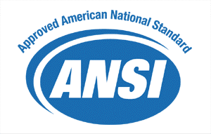
Approved ANSI Integrated Design Standard for Buildings & Communities
which saves a documented 1% in construction costs and more in operations.

Conducts Green Cities® Conferences for Business & Government: http://greencities.com.

MTS is a non profit public charity comprised of leading environmental groups, governments, and companies increasing market penetration of green buildings and sustainable products and the subsequent global, health, environmental, economic, and social benefits. Board Membership is by invitation only.

Members are market leaders. Corporate Fortune 500 Members take the lead on MTS programs that increase their profitability, and join and Partner with MTS because they derive the most value in leading the market, simultaneously helping others and the public good.

Since the public does not believe corporate self-promotion on the environment, MTS' programs provide the greatest value for companies that frequently communicate on their environmental activities and meet MTS Sustainable Products Standards.

MTS programs greatly contributed to the 75% sustainable products growth rate over the past six years.

